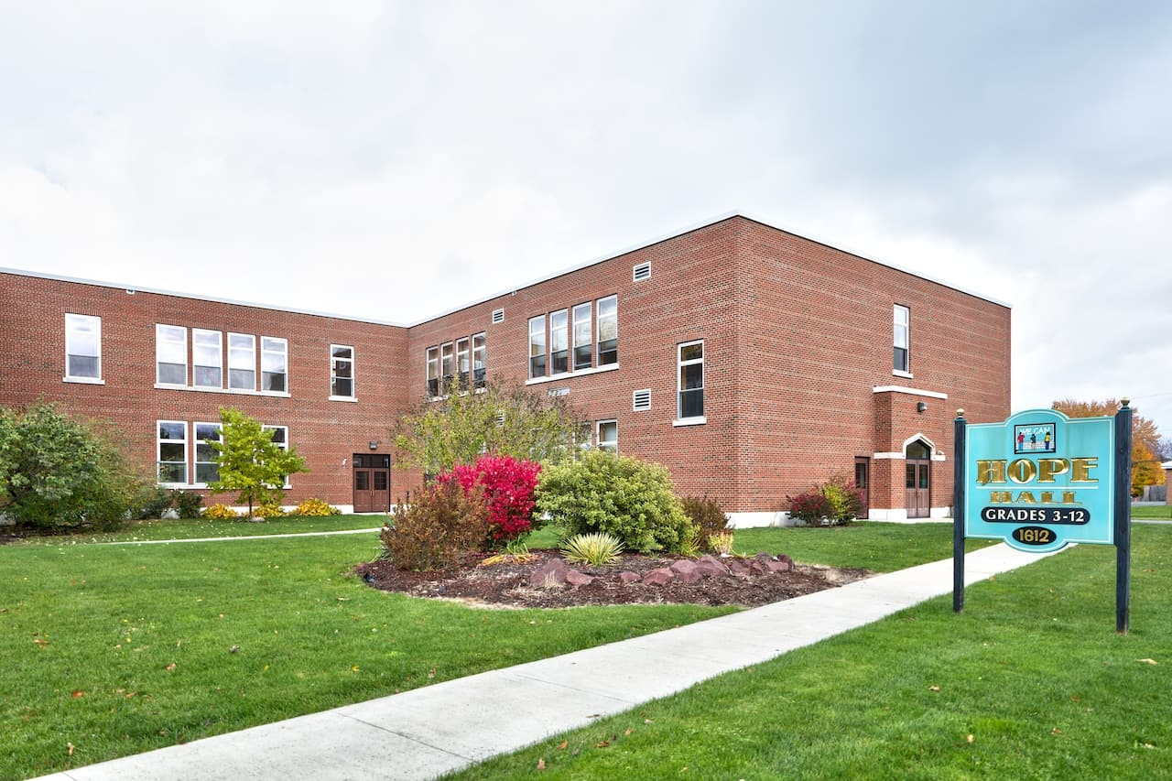

MINIMUM CAPACITY :-

The Minumum intake capacity

of students is between 300-620

children

LIBRARY :-

The Libarary is Available.

CANTEEN:-

The Canteen Facility is Available.

BOARDING :-

No availablility of boarding.

SPORTS :-

There are different categories

sports available.

Girls Volleyball

Boys Volleyball

Football

|  |  |  |
| --- | --- | --- |
| HOPE HALL SCHOOL  ROCHESTER - SCHOOL |  |  |
|  |  |  |
| School Detail :- Established in 1994, Hope Hall School provides an opportunity for educationally marginalized children to become successful lifelong learners. Serving students in grades 3 through 12 from school districts across the Greater Rochester Area, Hope Hall’s nurturing, non-threatening, creative atmosphere encourages students to take risks in learning and helps them reverse the cycle of academic failure. Hope Hall is a private, non-sectarian, 501(c)(3) not-for-profit school designed for students with special learning needs. Our students consistently experience frustration in the traditional classroom setting. We are committed to the belief that when students are given respect and enough time in a supportive, creative, multi-sensory learning environment, they can become successful learners. |  |
|